Influencer Campaign and Survey Report (TRI)

Jennyfer Aguirre, Daniel Robles, Lucynda Young, Matthew Melger
IBM 6010: Digital Marketing
December 2, 2024

Company Missions/Vision
TRI’s vision is to “Inspire a world where individuals and communities wholeheartedly embrace their common humanity and are empowered to nurture their inherent resiliency”(Trauma Resource Institute, n.d.). Their mission, as stated on their website is to empower the community through ideas and skills based on neuroscience. They train their community with skills that are “accessible, affordable, adaptable, and transportable”(Trauma Resource Institute, n.d.). This approach ensures that individuals from all walks of life benefit from the programs they offer. Moreover, TRI is dedicated to form leaders and professionals to be equipped with all the tools they need to make an impact in the field of trauma and resiliency.
Core Competencies
The Trauma Resource Institute (TRI) is a non-profit organization dedicated to improving the lives of individuals and communities affected by trauma. Its core competencies focus on the development and delivery of trauma-informed care and trauma-healing resources. One of the main core competencies is trauma-informed care, which provides training to professionals on understanding trauma and how it affects individuals. They also have various trauma-healing practices.

Core competencies for TRI, specifically in trauma-informed care, would include the following:

1. Understanding Trauma and Its Impact: Knowledge of Trauma: Awareness of the various types of trauma (e.g., childhood trauma, complex trauma, PTSD) and the physiological, emotional, and psychological impacts of trauma on individuals.

2. Trauma-Informed Care Approach
Safety and Trust: Creating environments that prioritize physical and emotional safety for clients, ensuring they feel secure and respected.
Empowerment and Choice: Supporting individuals in regaining control over their lives by offering them choices and promoting autonomy.

3. Skills in Resilience BuildingStrengths-Based Approach: Focusing on the strengths, resources, and coping mechanisms individuals already possess, rather than solely on deficits or pathology.
Resilience Skills: Teaching and supporting clients in building resilience and coping skills, which may include emotional regulation, grounding techniques, and mindfulness practices.

4. Psychosocial Support and Interventions
Crisis Intervention: Ability to provide immediate support to individuals in crisis, with an understanding of de-escalation techniques, safety planning, and trauma-sensitive approaches.

Business Objectives and Project Objectives
The business objectives of TRI revolve around its long-term sustainability, growth, and impact. With this long term growth model they would like to continue to support individuals and communities who have been trauma-affected to expand its reach, and foster meaningful partnerships. Increasing the number of traffic to be inclusive of more mental health professionals and people who are seeking out resources. Also to develop and deliver a growing number of workshops, webinars, and certification programs to reach a broader audience across diverse sectors. As well as strengthen TRI’s presence in the trauma-informed care and mental health fields to raise awareness and promote systemic change. As for the project objectives are more specific and directly tied to the outcomes of particular initiatives or programs. They are typically measurable and time-bound, designed to fulfill particular needs of communities or specific groups served by TRI. Which will Equip the professionals with trauma-informed practices that they can implement within their workplaces and communities.

Business Objectives for the Trauma Resource Institute (TRI):
- Expand Reach and Impact:
- Objective: Increase the number of organizations, communities, and individuals trained in trauma-informed care.
- Measure: Grow the number of training programs offered and the total number of participants (e.g., schools, healthcare providers, social services, etc.).
- Goal: Extend TRI's influence and network, reaching underserved communities and global audiences.

2. Establish TRI as a Leading Authority in Trauma-Informed Practices
- Objective: Position TRI as a thought leader in trauma-informed care and practices.
- Measure: Increase in TRI's visibility through speaking engagements, publications, and collaborations with other organizations.
- Goal: Influence policy and practice through education, research, and advocacy, contributing to the national/global trauma-informed movement.

3. Create Scalable, Sustainable Educational Resources
- Objective: Develop and deliver scalable, online, and in-person training programs and materials that can be adapted across various sectors (e.g., healthcare, education, social services).
- Measure: Increase in online course enrollments, feedback from participants, and implementation of knowledge by participants in their professional environments.
- Goal: Establish a scalable model for training and education that can reach a wide range of audiences globally.

As for project objectives
- :Create a Trauma-Informed Training Curriculum for Healthcare Providers
- Objective: Develop a comprehensive, evidence-based training program designed specifically for healthcare providers (e.g., doctors, nurses, therapists) to understand and respond to trauma effectively.
- Measure: Completion of curriculum development, number of healthcare organizations adopting the program, and feedback from healthcare providers.
- Goal: Equip healthcare professionals with trauma-informed tools to enhance patient care and recovery outcomes.
Host National Trauma-Informed Care Conferences and Events
- Objective: Organize an annual or biennial conference to bring together experts, practitioners, and communities to share knowledge, research, and best practices in trauma-informed care.
- Measure: Number of attendees, quality of speaker presentations, and post-event surveys on attendee satisfaction and takeaways.
- Goal: Foster a national (or global) network of trauma-informed professionals and advocates who can collaborate on improving care for trauma survivors.

Company Background
Trauma Resource Institute (TRI) is a nonprofit organization who were founded on a dedication to cultivating trauma-informed and resiliency-focused specialists and communities worldwide. Founded in 2006, TRI has developed and implemented models to help people understand and manage the effects of trauma and stress, and provide trainings for individuals looking to support their community through their own use of these models. TRI’s models have been introduced in 75 countries across various continents, including Asia, Africa, North America, Australia, the Middle East, South America, and Europe. Given TRI is known internationally for its innovative perspectives promoting individual and community well-being.

The organization is led by CEO Dr. Michael Sapp, who has been actively involved since 2010, initially serving as Senior Faculty for both TRM and CRM. Under his leadership, TRI have expanded their global reach, strategically providing support and training in regions affected by natural disasters, conflicts, and other crises.

TRI's commitment to accessibility is evident in their development of the iChill app, which guides users through wellness skills to manage sensations associated with trauma and stress. The app is available in multiple languages, including English, Arabic, Spanish, Hebrew, and Ukrainian.
Overall, TRI maintains a strong position in the field of trauma education and intervention, continually expanding its global impact and providing valuable resources to diverse populations.

- Trauma Resiliency Model (TRM)®: Designed for mental health professionals, TRM focuses on understanding the biological effects of trauma and teaches specific skills to restore balance to the body and mind after traumatic events.
- Community Resiliency Model (CRM)®: Aimed at the general public, CRM provides wellness skills to help individuals manage stress and trauma, promoting community-wide resilience.

Marketing Team’s Expertise
The organization's global reach and the widespread adoption of its models indicate effective dissemination and outreach strategies. The development of the iChill app, available in multiple languages, further suggests a strategic approach to accessibility and user engagement. Given their current marketing strategies and advertising strategies, there remains room for the company to capitalize on the use of a wider array of Omnichannel marketing methods. These could include wider social media market reach methods, influencer campaigns, website optimization and more.

Current Target Markets and Positioning
TRI primarily targets:
- Mental Health Professionals: Through the TRM program, providing specialized training to enhance therapeutic practices.

General Public and Community Leaders: Via the CRM program, offering tools to build resilience and manage stress within communities.

The organization positions itself as a leader in trauma education and intervention, emphasizing accessible, affordable, and culturally sensitive approaches.
Products

Trauma Resiliency Model (TRM)®: Training for mental health professionals focusing on the biological impacts of trauma.

Community Resiliency Model (CRM)®: Training for community members to develop and teach wellness skills.

iChill App: A mobile application guiding users through wellness skills to manage sensations associated with trauma and stress, available in multiple languages.
Pricing
TRI's training programs and resources are designed to be accessible and affordable.

Marketing Channels
TRI utilizes various channels to reach its audience:
- Website: Provides comprehensive information about programs, resources, and training opportunities.
- Social Media: Engages with a global audience to share updates and resources.
- iChill App: Extends reach by offering accessible tools for managing stress and trauma.
- Collaborations and Partnerships: Works with organizations like the United Nations Population Fund to expand program reach.

Integrated Marketing Communications
TRI appears to implement an integrated marketing communications strategy by:
- Consistent Messaging: Ensuring all communications reflect the organization's mission and values.
- Multichannel Engagement: Utilizing various platforms to disseminate information and resources.
- Global Outreach: Tailoring programs and materials to meet the cultural and linguistic needs of diverse populations.
- This approach helps TRI maintain a cohesive brand presence and effectively reach its target audiences.

TRI Website:
TRI can implement a multitude of SEO and SEM methods in order to optimize their website to increase conversion rates, leads, sales and work toward building a community. The company can implement a conversion-centered design to revamp their page with adjustments geared towards action items drawing more conversion rates and click through rates. Different touch points for improving the design would include retaining consumer attention while on the site, clarity for action items, increasing the user’s sense of credibility for the site, and navigation for the website.
Competitive Analysis

Digital Marketing Channels/Effort 1

Why a Quiz would help in the digital marketing efforts:
Using a quiz strategy to determine the TRM (Trauma Resiliency Model) or CRM (Community Resiliency Model) preferences for the Trauma Resource Institute (TRI) can enhance their marketing efforts by leveraging insights from competitor analysis
- Customer Insights: A quiz helps TRI segment users based on their specific needs or interests (e.g., individuals, communities, professionals), allowing for personalized outreach.
- Engagement: Interactive quizzes attract attention and keep users engaged longer. By asking questions that help users identify whether TRM or CRM fits their needs, TRI can create an immediate sense of relevance, increasing trust and likelihood of engagement.
- Competitor Benchmarking: Through competitor analysis, TRI can identify gaps in competitor strategies (e.g., inadequate focus on personal engagement tools) and position their quiz as a unique feature.
- Exposure: A well-crafted quiz is shareable, promoting TRI organically via social media and other channels.
- Lead Generation: Quizzes are excellent tools for capturing user information, such as contact details or preferences. They can act as a subtle form of lead magnet, offering personalized resources in exchange for user responses.
- Differentiation: Competitor analysis aids in understanding market gaps. If competitors don’t use such tools, TRI’s quiz would stand out, showcasing innovation in connecting with the audience.
- Segmentation for Personalized Marketing: By gathering user data, TRI can tailor marketing campaigns, sending content specific to the user's interest in TRM or CRM. This personalization aligns with competitor strategies to improve conversion rates.
- Social Media Sharing and Organic Exposure: Quizzes are inherently shareable. A well-designed one could attract new users when shared by participants, organically increasing TRI’s reach without significant additional marketing spend.
- Analytics for Refinement: Tracking quiz results provides insights into audience preferences, helping TRI refine their messaging and offerings. For example, if most users lean towards CRM, TRI can invest more in marketing that model.

By applying these strategies effectively, TRI can increase awareness, establish its expertise, and drive engagement across key audience segments.

Digital Marketing Channels/Effort 2
Influencer Campaigns
Upon analyzing the strategies of competitors and their use of influencer campaigns, it became evident that none have initiated these efforts. TRI would be pioneering in this specific market.
For instance, a review of the National Child Traumatic Stress Network's (NCTSN) Instagram revealed no trace of influencer campaigns. Neither in the present or past. Their content is predominantly informational, with no story highlights indicating past campaigns with influencers or videos featuring influencers.
Similarly, the Crisis and Trauma Resource Institute's Facebook page showed no evidence of influencer campaigns. While their page shows plenty of information on their services and resources, including guest blog posts like "9 Strategies for Supporting Someone with BPD" by AnnMarie Churchill, there was no mention of influencer-driven initiatives.
The National Institute of Mental Health (NIMH) has many branches of social media platforms, including Instagram, Facebook, LinkedIn, X, and YouTube. However, their posts are primarily informational, like the previous competitors, featuring guest speakers and a few informational posts, with no signs of influencer campaigns.
In conclusion, highly relevant competitors primarily use their social media platforms to provide information and have not engaged in influencer campaigns like the one proposed for TRI. This presents a unique opportunity for TRI to innovate and stand out from competitors in this market.

Recommended Digital Marketing Strategy
Target Market
To develop a recommended digital marketing strategy for targeting the Trauma Resource Institute's (TRI) audience effectively. Below are detailed, actionable points tailored to TRI's needs:

1. Develop Specific and Relevant Keyword Campaigns
- Action: Create keyword lists focused on terms like "trauma recovery tools," "resilience training programs," and "mental health crisis support." Use long-tail keywords to attract highly specific traffic.
- Benefit: These keywords align with the needs of users searching for TRI’s offerings and enhance ad relevance, lowering costs and increasing click-through rates.

2. Craft Compelling Ad Copy
- Action: Write ad copy that highlights TRI’s unique services, such as the Community Resiliency Model (CRM) or Trauma Resiliency Model (TRM), and emphasize outcomes like "effective trauma recovery" or "stress resilience training."
- Benefit: Well-structured and persuasive ads ensure better user engagement, leading to higher conversion rates.

3. Optimize Landing Pages for Conversions
- Action: Design landing pages specific to each ad group, featuring clear calls to action (e.g., "Sign up for CRM Training" or "Download a Free Resilience Guide"). Incorporate testimonials and interactive elements like quick surveys.
- Benefit: A targeted, user-centric landing page boosts conversions by providing a seamless user experience.

4. Leverage Geo-Targeting
- Action: Use geo-targeting to focus on areas where TRI training workshops or programs are most needed, such as regions with high disaster rates or underserved mental health areas.
- Benefit: Tailoring ad reach geographically increases the likelihood of connecting with audiences who can directly benefit from TRI's services.

5. Run A/B Testing
- Action: Continuously test ad variations and landing page designs to determine what resonates best with TRI’s target audience.
- Benefit: A/B testing allows TRI to optimize its campaigns dynamically, ensuring maximum ROI from digital marketing efforts.

6. Utilize Analytics for Campaign Refinement
- Action: Track metrics such as cost per conversion, bounce rates, and ad engagement to refine campaign performance over time.
- Benefit: Regular data analysis helps TRI adjust its approach, ensuring sustained effectiveness and efficiency

7. Incorporate Remarketing
- Action: Use remarketing ads to re-engage users who visited TRI’s website but did not convert. Highlight offers like free workshops or success stories.
- Benefit: Remarketing keeps TRI’s services top-of-mind for potential clients, increasing the chance of conversion over time.
These strategies create a cohesive plan to enhance TRI’s digital presence, attract the right audience, and increase engagement with its mental health resources.

SWOT ANALYSIS

Strengths
- Expertise and Credibility in Trauma-Informed Care
  - Established Authority: TRI has deep expertise in trauma-informed care, with a strong reputation for providing evidence-based education, training, and resources for organizations and communities.
  - Recognized Training Programs: TRI's comprehensive and practical training programs are widely respected across sectors like healthcare, education, social services, and criminal justice.

Weaknesses
- Resource Constraints for Expansion
  - Limited Financial Resources: As a nonprofit organization, TRI may face challenges in securing the funding needed to expand its programs and operations, particularly in global markets.
  - Dependence on Grants and Donations: Reliance on external funding sources (e.g., grants, donations) can create instability and hinder long-term financial planning and growth.
- Scalability Challenges
  - Customization Requirements: While TRI offers flexible training, adapting programs to local contexts can be resource-intensive. Scaling globally while maintaining high-quality, culturally sensitive programs may require significant investment.
  - Overextension of Resources: Expanding into too many sectors (e.g., healthcare, education, social services, corporate settings) could overextend TRI’s resources and diminish the focus on its core expertise.

Opportunities
- Growing Demand for Trauma-Informed Practices
  - Increasing Awareness of Trauma's Impact: As awareness of trauma's impact on physical and mental health grows, demand for trauma-informed practices is likely to increase across various sectors, including healthcare, education, social services, and even the workplace.
  - Post-Pandemic Needs: The COVID-19 pandemic has exacerbated trauma in many communities, creating a heightened demand for trauma-informed approaches in healthcare, social services, education, and beyond.

Threats
- Competition from Other Trauma-Informed Care Providers
  - Emerging Competitors: Other organizations offering trauma-informed training, therapy, and resources may enter the market, creating increased competition for funding and attention. Some competitors may also offer more specialized or niche services that attract specific sectors or groups.

Positioning

"The Trauma Resource Institute (TRI) empowers individuals, organizations, and communities with trauma-informed tools, training, and resources to create environments of safety, healing, and resilience. Through evidence-based education and a commitment to compassion, TRI enables systems of care, professionals, and everyday people to understand the deep impact of trauma and help build pathways to healing and recovery."

A. Target Audience
TRI serves a wide array of professionals and organizations across multiple sectors, each facing the challenge of supporting individuals impacted by trauma:
- Healthcare Providers (doctors, nurses, social workers, mental health professionals)
- Educators (teachers, counselors, school administrators)
- Social Service Agencies (nonprofits, child welfare workers, community leaders)
- Workplaces (HR departments, corporate wellness teams)
- Public Policy and Advocates (government agencies, policy influencers)
- Communities and Grassroots Organizations (individuals, families, cultural organizations)

B. Core Differentiators
TRI differentiates itself through several key aspects that make its offerings unique in the field of trauma-informed care:
- Holistic and Resilience-Focused Approach:
  - While many trauma programs focus on identifying and responding to trauma symptoms, TRI goes beyond symptom management by emphasizing resilience and healing. This resilience-focused approach empowers individuals and communities not just to survive trauma, but to recover and thrive.
- Scientific Basis Combined with Compassionate Practice:
  - TRI integrates cutting-edge neuroscience and evidence-based trauma recovery models with a deep commitment to human dignity and compassion. This combination of scientific rigor and empathetic care sets TRI apart from other trauma-related programs.

Positioning Goals
- Establish TRI as the Leading Resource for Trauma-Informed Care:
  - Goal: Position TRI as the go-to authority for trauma-informed education, tools, and research.
  - Rationale: As trauma awareness and care become increasingly critical across sectors, TRI aims to be the trusted resource for professionals and organizations seeking to integrate trauma-informed principles into their practice.

Target Audience
- Individuals: Those affected by trauma, including survivors of abuse, conflict, natural disasters, or systemic violence.
- Professionals: Healthcare workers, educators, social workers, therapists, first responders, and anyone in a position to provide support to trauma-affected individuals.
- Communities: Communities or populations dealing with collective trauma, including refugee populations, indigenous communities, or marginalized groups.
Brand Personality
- Compassionate: TRI's tone and approach are grounded in empathy, with a deep understanding of the challenges faced by trauma survivors and the need for compassion in healing.
- Empowering: TRI helps individuals and communities to become self-reliant in their healing, building their own capacity to cope with and overcome trauma.
Value Proposition
- Holistic Healing: TRI focuses on body-based and somatic approaches (e.g., Trauma Resilience Model) to heal trauma, recognizing that trauma affects not just the mind but also the body and nervous system.
- Trauma-Informed Practices: TRI provides evidence-based trauma-informed training and resources, helping organizations and communities create supportive environments that are sensitive to the needs of trauma survivors.
- Resilience Building: Emphasizing resilience rather than just recovery, TRI equips people with tools to not only heal but to thrive and grow stronger from their experiences.

Digital Marketing Channels/Effort 1
Implementation for the Quiz
A recommendation we insist on is to create and implement the quiz for TRI effectively, it is crucial to strategically position it where the target audience is most likely to engage. Here's a breakdown of the best placements for the quiz and why they are effective:

Recommended Placements for the Quiz
1. Website Homepage (Pop-Up or Banner) and also in their first headline text where the “how to help” button is.
- Why: Pop-ups or banners on the homepage immediately catch the attention of visitors, especially first-time users exploring TRI. A headline like “Discover Your Path to Resiliency—Take Our Quiz!” can draw interest.
- Effectiveness: It ensures maximum visibility and encourages users to explore TRI’s offerings from the outset.
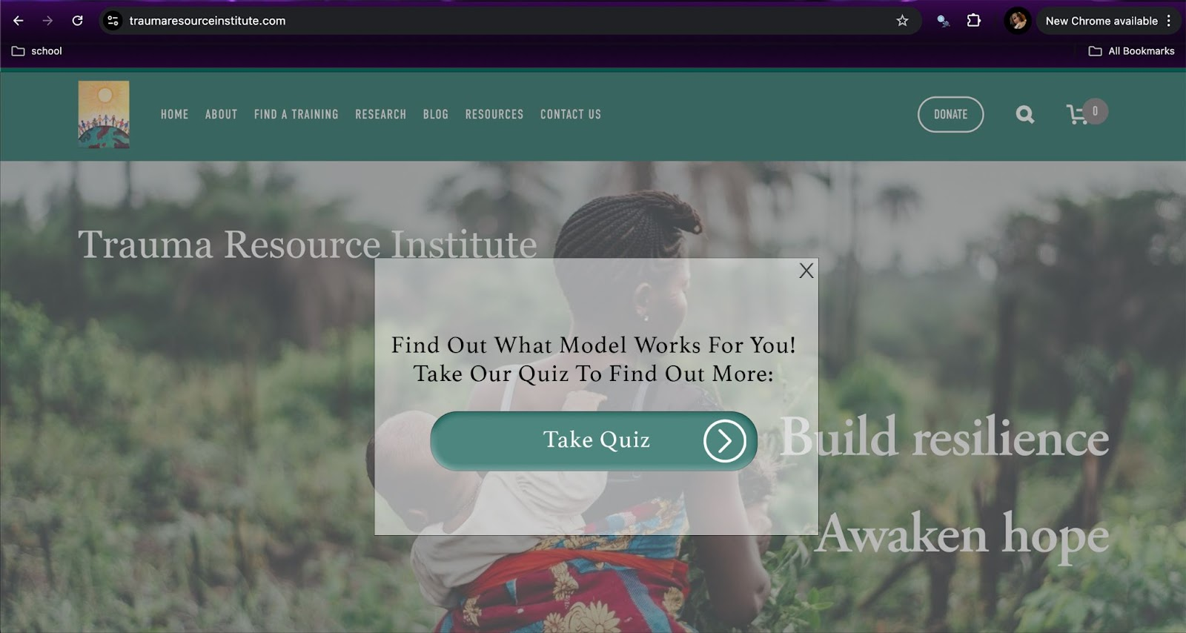
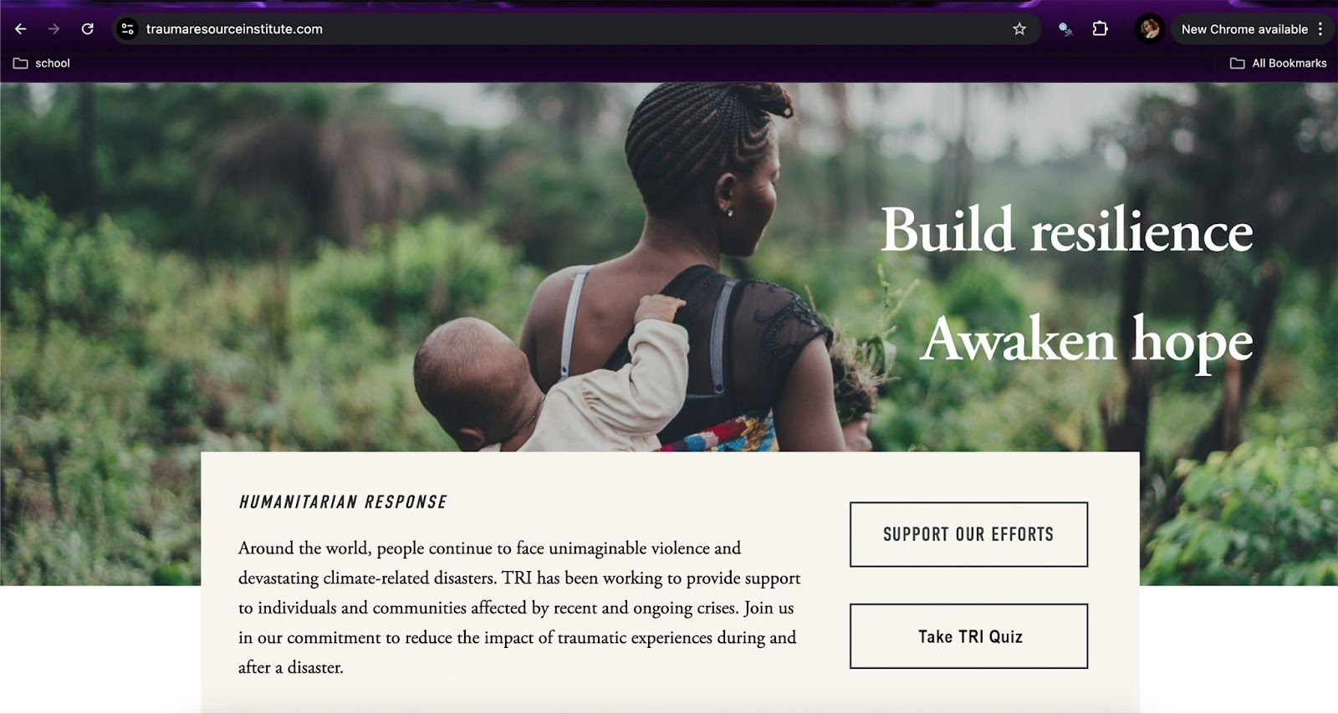
2. The "Model" Section or Pages (TRM and CRM Pages)
- Why: Visitors exploring these pages are likely already interested in TRI’s models and can use the quiz to determine which model suits their needs.
- Effectiveness: Placement here ensures the quiz is relevant to the content users are already consuming, increasing the likelihood of interaction.
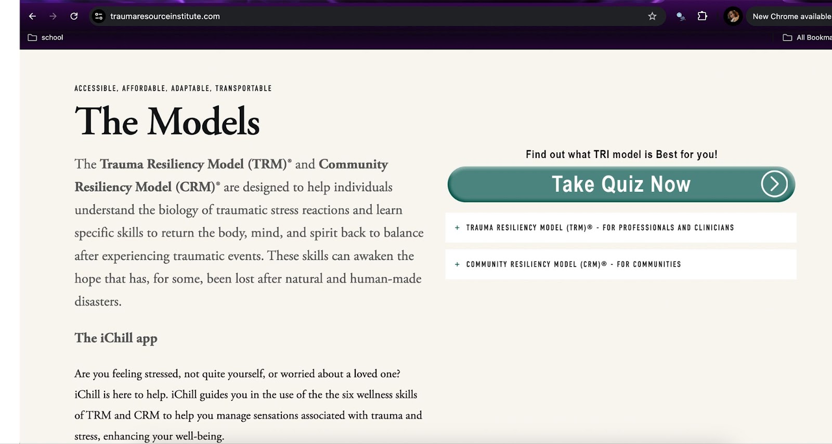
3. Navigation Drop-Down Menu
- Why: Including a link labeled “Find Your Model: TRM or CRM?” in the navigation bar ensures the quiz is always accessible, regardless of the page the user is on.
- Effectiveness: This creates a seamless user experience by integrating the quiz into the site's structure, making it easy to find and use.
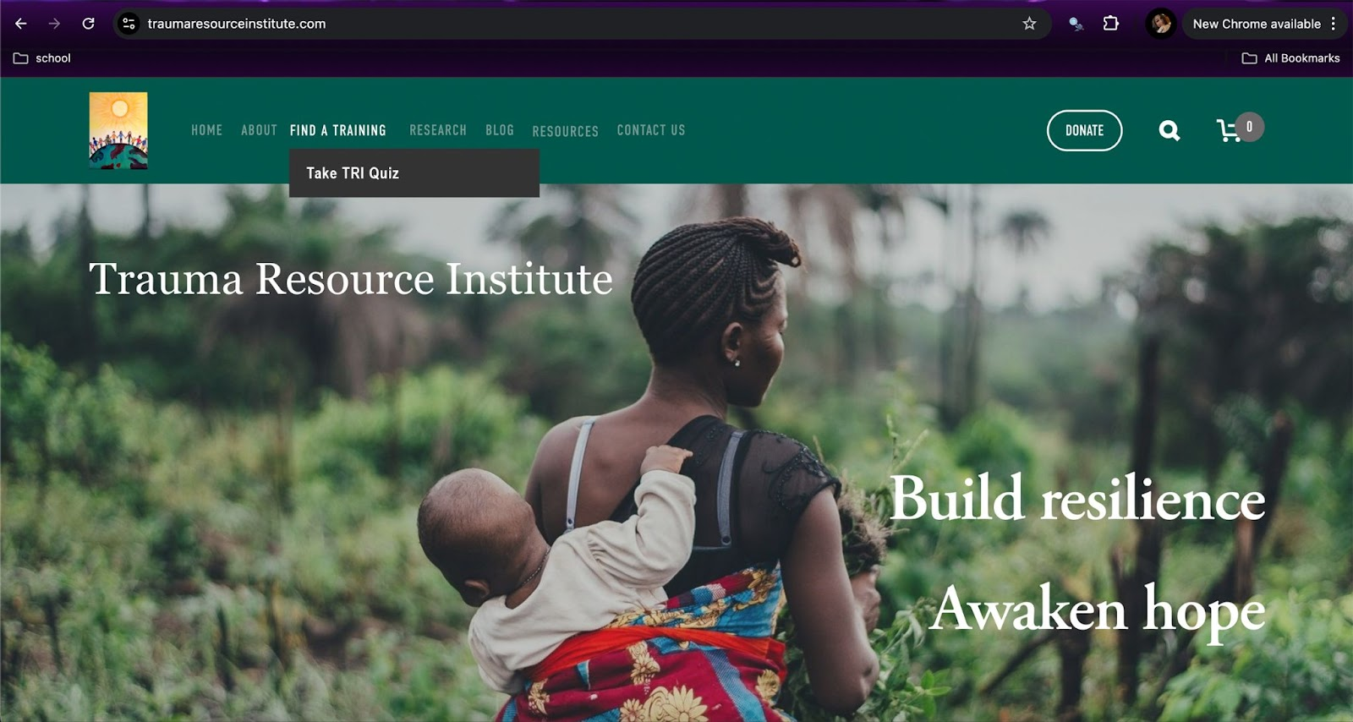
4. Email Marketing Campaigns
- Why: Sending the quiz via email to TRI’s existing contact lists can re-engage past participants or reach those interested in trauma recovery resources.
- Effectiveness: Personalized email campaigns with subject lines like “Which Resiliency Model Fits You Best?” can drive traffic back to the site.
5. Influencer Campaigns (See our recommendations below for influencer campaigns)
- Why: Collaborating with mental health professionals or community influencers to promote the quiz on platforms like Instagram, LinkedIn, and Facebook ensures TRI reaches new audiences.
- Effectiveness: Influencers can lend credibility and expand the reach of the quiz to a broader audience.

Why This Quiz is Innovative
- Personalization at Scale: By offering tailored outcomes (e.g., recommending TRM for therapists or CRM for educators), the quiz creates a highly personalized experience that competitors may not offer.
- Interactive Engagement: Quizzes are more engaging than static content, encouraging users to spend more time on TRI’s website and learn about its offerings organically.
- Actionable Insights: The data collected from quiz responses can provide TRI with valuable insights into user preferences, which can be used to refine marketing strategies and improve content delivery.

How the Quiz Gives TRI a Competitive Edge
- Differentiation: Many competitors likely rely on static resources like articles or webinars. An interactive quiz positions TRI as innovative and user-focused.
- Enhanced Shareability: Quizzes are inherently shareable. Users are more likely to share their results or recommend the quiz to others, increasing organic traffic and awareness.
- Lead Generation: The quiz can ask for email addresses in exchange for results, building a database of potential clients or collaborators for follow-up campaigns.

Additional Benefits
- Guided Decision-Making: It helps visitors navigate TRI’s offerings more effectively, increasing their confidence in the organization’s resources.
- Increased Conversions: A quiz can guide undecided visitors towards actionable steps, such as signing up for training sessions or downloading free materials.
This strategy leverages on strategic placement, clear calls to action, and data-driven insights to maximize the quiz's effectiveness in marketing TRI’s unique services.
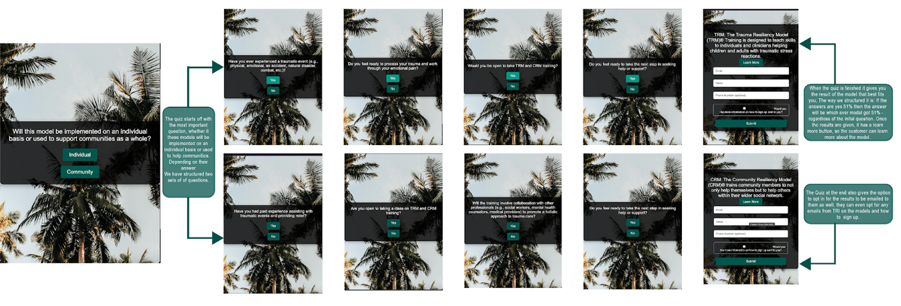

Digital Marketing Channels/Effort 2
Influencer Campaign
Our recommendations for the influencer campaign are to have two branches of influencers- influencers that are organically already interested in TRI through Instagram followers and influencers that are available for paid advertising to their audiences through content creation.
Influencers from influencer site: Collabstr
We identified 34 influencers who could align well with TRI’s mission and purpose statements. After careful curation, we refined this list to three potential influencers in every price range- from low to medium and high. To begin, we recommend engaging with the three influencers in the lower price range to test the campaign's effectiveness. This approach allows us to gauge success and make any necessary adjustments before investing in higher-priced influencers.
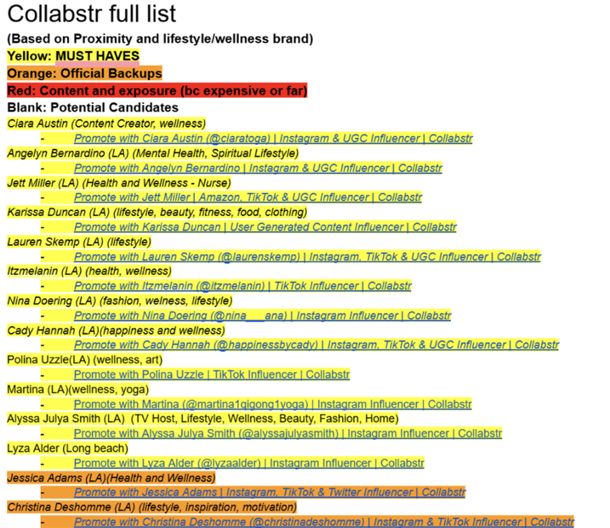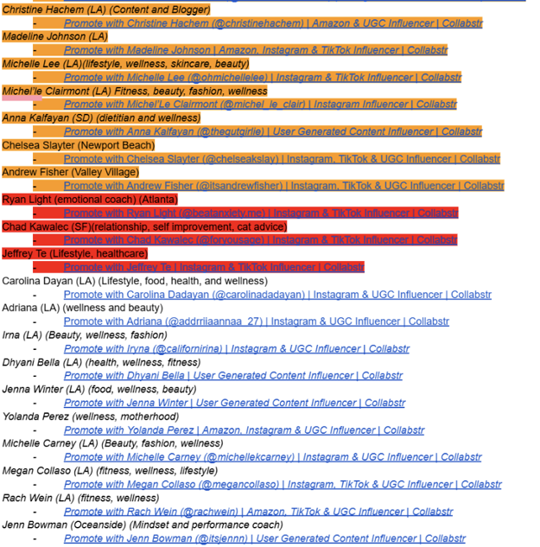

Influencers from Instagram
With an influencer campaign geared towards consumers on Instagram, 25 potential candidates for the position were selected, funneled down to about 10 which were likely to be a good fit, and 8 who were very likely to be a good fit and match the necessary criteria such as follower counts and post frequency. TRI can approach these influencers with a means to present the position as an opportunity to be a part of the non-profit organization with the benefit of increasing their exposure in the industry.
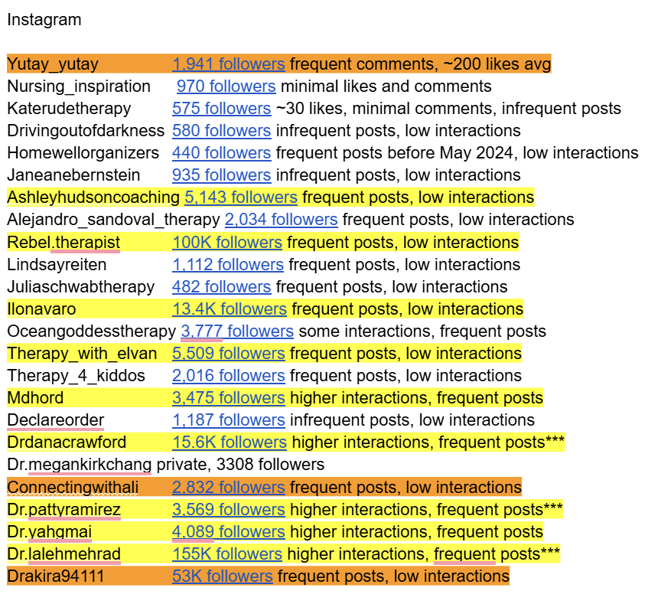
Initial Contact:
The initial contact for Collabstr is simple, since the site facilitates the exchange through an “add to cart” method. If necessary, TRI can also reach out via direct message on the influencer’s preferred platform to negotiate a better price or to introduce TRI’s services as a gift in exchange for a video. If using the direct message route, the initial contact template (refer to figure 1) should be utilized, and this also applies to outreach through Instagram. Once the influencer is on board (refer to figure 2), there must be a clear guideline on whether the influencer will be recording an experience video for the free training or an informational and call-to-action video. Further questions and clarifications may arise, so providing a mock script (figure 3) can assist influencers who are unsure how to create content in this manner. The content creation should be categorized into two types: experiential and informational.

Figure 1
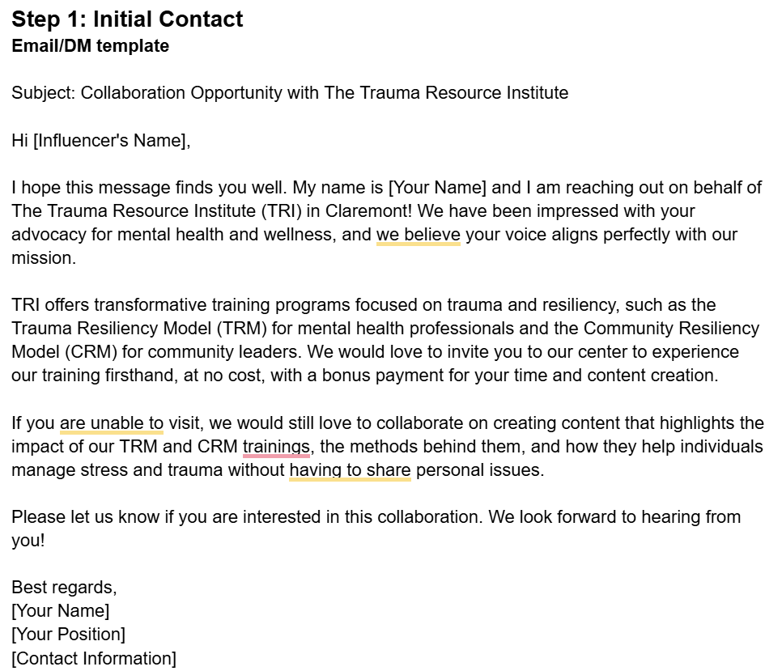

Figure 2
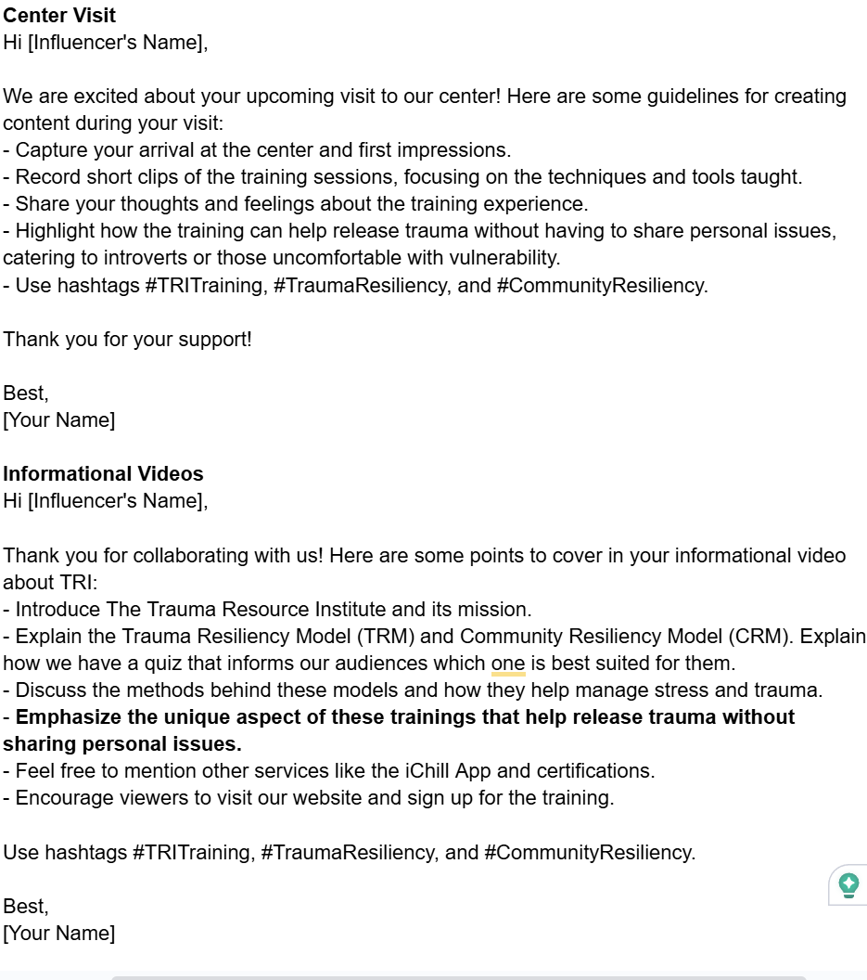

Figure 3
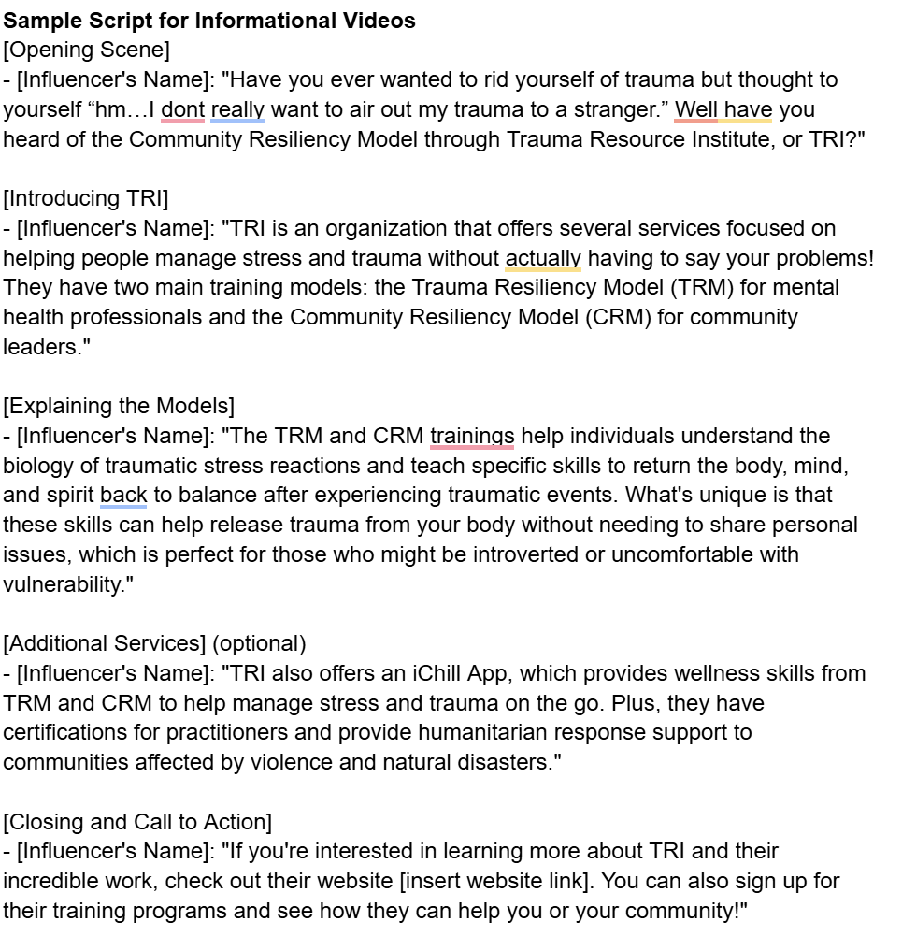
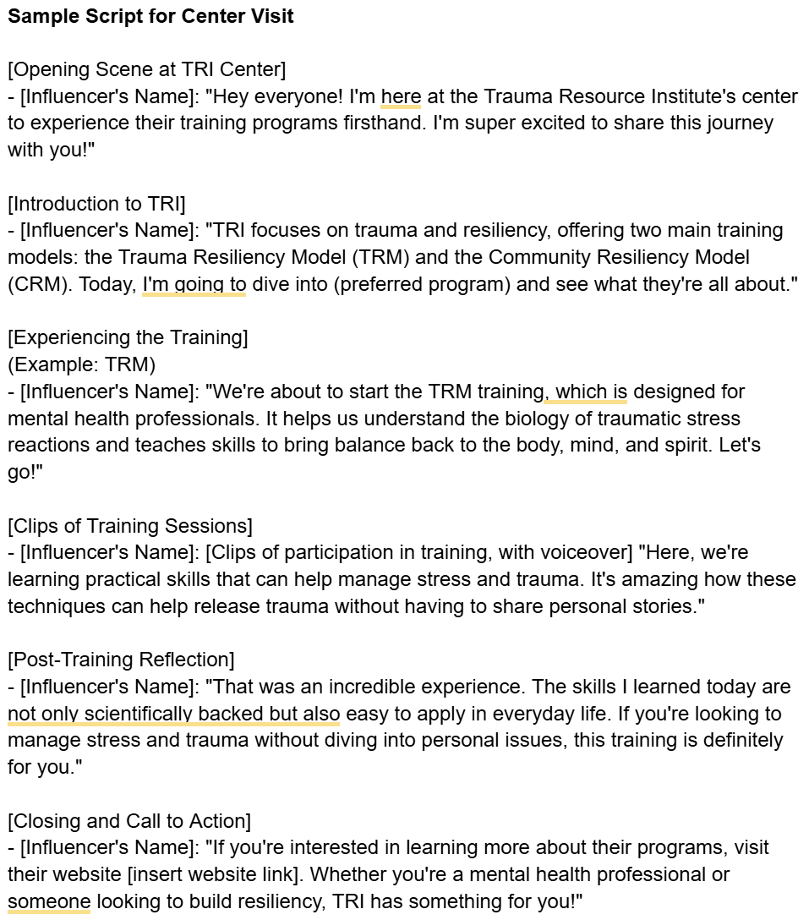

Conclusion
The combination of a strong, conversion-centered website design, interactive tools like quizzes, targeted digital marketing channels, and innovative influencer campaigns will place TRI in a competitive position to expand its reach and impact. By strategically leveraging these digital marketing strategies, TRI can foster deeper engagement with its target audience, increase brand recognition, and ultimately drive greater adoption of its trauma-informed programs.
The key to TRI’s success lies in maintaining a balance between evidence-based practices and compassionate engagement, offering audiences a personalized, valuable experience at every touchpoint. As TRI pioneers new avenues in digital marketing, it will not only lead in educating about trauma-informed care but also become the leading resource for individuals and organizations seeking to build resilience and healing.

Appendix

